Promoting Ramsey

Project Evaluation Report
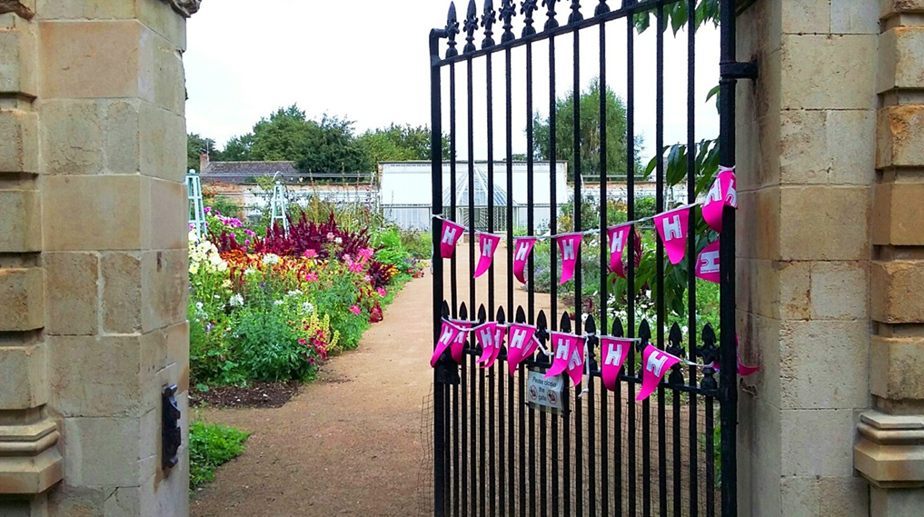
A final evaluation of the Big Local-funded ‘Promoting Ramsey’ Project – October 2017

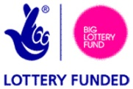

Contents

- Summary

- Introduction to the Promoting Ramsey project

  - Project aims

  - Methods of evaluation

- Assessing the delivery of Specific Aim 1 – To create and deliver a strategy for promoting heritage business and tourism in Ramsey

  - Have the needs of local heritage and tourism businesses been understood and factored into the promotional strategy? Have they been involved?
    - Local Residents
    - Steering Group
    - Local Business
    - Heritage Attractions
    - Awareness of project

  - Do local people have a pride in Ramsey? Do people have a better understanding of what Ramsey has to offer them for leisure and retail? Are the website and social media are being used?
    - Local Pride
    - One Single Brand
    - Awareness Levels of Events
    - Website and Social Media
    - Other Websites
    - Press Releases

  - Are groups working better together? Are there more joint events being delivered?
    - Heritage Group Meetings
    - Arts Groups
    - Partnerships outside Ramsey

- Assessing the delivery of Specific Aim 2 - To make Ramsey’s heritage and tourism offer more appealing to visitors

  - Are Ramsey’s heritage and tourism attractions being better used?
    - Heritage Sites more visited
    - National Heritage Open Day
    - Visitors from outside Ramsey
    - Two Spring Heritage Days: Duck Race and A Journey Through Time
    - Use of Heritage Sites

- Assessing the delivery of Specific Aim 3 - To increase individual and community capacity for taking forward own ideas for revitalising Ramsey

  - Are individuals and community groups involved in a meaningful way in partnership with each other?
    - Steering Group Meetings
    - Heritage Group Meetings
    - Exhibitions

  - Are volunteers gaining skills in destination marketing and promotion?
    - Visitor Information Points

  - Do volunteers feel confident promoting Ramsey with those they come into contact with?
    - Volunteers at events
    - Volunteers at Visitor Information Points

- What could have been done differently and other influencing factors

  - What could have been done differently
    - Re-profiling of the project
    - Media coverage
    - More involvement of local business

  - Other influencing factors
    - A local project officer
    - Team working
    - Big Local
    - Strength of brand
    - A wide range of events
    - Heritage groups and business work together
    - Wider promotion
    - Budget

Appendix 1: Perception Survey conducted June 2015

Appendix 2: General Questionnaire conducted November 2016

Appendix 3: Perception Survey conducted July 2017

Appendix 4: ‘The story of the brand’ leaflet

Appendix 5: Resources produced

Appendix 6: How this could be used elsewhere

- Summary

This report aims to answer the question of whether the Promoting Ramsey project has met its three specific aims. In summary:

- All activity has been delivered within budget.

- A strategy for promoting Ramsey was created and delivered on time.

- Heritage, business, tourism and community groups were consulted, involved and worked together on the project.

- A single brand and a website with social media platforms were delivered ahead of schedule.

- 96% have seen and recognised the branding, 84% are aware of the Promoting Ramsey project and 48% had seen the Discover Ramsey website (Survey November 2016).

- Positive feelings about living in Ramsey have improved – only 4% felt that there was a less positive feeling about the town compared with 2 years ago.

- Awareness of project events is high: heritage days 83%, craft festival 83%, Gaiety Night 66%.

- Ramsey’s presence online is growing: both on Discover Ramsey platforms and on other’s websites.

- Press releases have successful and have averaged a take up in the press of five per month.

- Heritage Open Days have doubled in number per year and visitor numbers have continually increased.

- The two Craft Street Festivals were the second busiest Saturdays of the year (Christmas Light switch on is the busiest).

- Partnership working with tourist destinations within 20 miles has been successful with around 450 Ramsey Open for Discovery folders being distributed from Ely, Peterborough and Cambridge tourist offices, accommodation providers and attractions. The website also features on Visit Cambridge, Visit Peterborough, National Heritage and Visit England.

- 500 Ramsey information Packs have been distributed at exhibitions and via retailers/hotels/camp sites/libraries etc in the local area.

- Visitor Information Points in Ramsey’s retailers, pubs, cafes and the library have distributed around 750 Ramsey Open for Discovery Folders and acted as good ambassadors for Ramsey.

- 12 events were held during the life of the project and all are being continued by community or heritage groups.

- Introduction to the Promoting Ramsey project

  - Project Aims

The Promoting Ramsey project was a two year project, funded by Big Local via the Ramsey Million Partnership, managed by Cambridgeshire ACRE. The overall aim of the project was to revitalise Ramsey Parish. To achieve this, three specific aims were identified:
- To create and deliver a strategy for promoting heritage, business and tourism in Ramsey.
- To make Ramsey’s heritage and tourism offer more appealing to visitors.
- To increase individual and community capacity for taking forward own ideas for revitalising Ramsey.

For each of these specific aims ‘outcomes’ (the change we intended to bring about) were identified, along with ‘outcome indicators’ (the measurements of success) – these are set out in Table 1 below. This evaluation report assesses the success, or otherwise, of the project when measured by these ‘outcome Indicators’.

Table 1: Summary of Specific Aims, Outcomes and Outcome Indicators

Specific Aim | Outcomes | Outcome Indicators
- To create and deliver a strategy for promoting heritage, business and tourism in Ramsey | Needs of local heritage and tourism businesses have been understood and factored into promotional strategy. | Heritage and tourism businesses are aware of the project and have been given the opportunity to be involved.
 | People have a better understanding of what Ramsey has to offer them for leisure and retail | Local people have pride in Ramsey.  People are using the Ramsey website and social media to find out more about events and activities.
 | Groups report that they are working better together. | Increased joint delivery of events.
- To make Ramsey’s heritage and tourism offer more appealing to visitors | Ramsey’s heritage and tourism attractions are better used. | Increased visitor numbers reported.  Length of visitor ‘dwell’ time.  Levels of attendance at special events.
- To increase individual and community capacity for taking forward own ideas for revitalising Ramsey | Meaningful involvement of individuals and community groups in partnership. | Number of business, heritage and tourism representatives on Working Group.  Extent to which representatives feel that their activity is making a difference.
 | Volunteers gain skills in destination marketing and promotions. | Extent of volunteer involvement in Town Ambassador scheme.  Number of volunteers contributing to Ramsey social media platforms.  Number of volunteer hours contributed to the revitalisation of Ramsey.
 | Volunteers feel confident in promoting the Ramsey Brand to those they come into contact with. | Level of volunteer confidence.  Range of events attended by volunteers.

As well as evaluating the project against its prescribed aims, this report will also examine what could have been done differently and other influencing factors that have been instrumental in making the project successful.

  - Methods of evaluation

Evaluation data for each ‘outcome indicator’ has been drawn from a number of different sources:
- Numerical indicators - visitor numbers, hits on website, numbers of press releases etc.
- Feedback from visitors, business, heritage volunteers and community.
- Surveys
  - Benchmarking Survey [May 2015] – 80 interviews across age range reflecting Ramsey’s demographics.
  - Perception Survey [June 2015] (Appendix 1) – an analysis of how those living in Ramsey Parish feel about where they live. 104 respondents plus focus groups.
  - Evaluation Survey [November 2016] - a general questionnaire (Appendix 2) undertaken by 64 participants representing heritage volunteers (6), town council members (4), community volunteers (11), Ramsey businesses (10), residents over 18 years (16) and residents between 12 – 14 years (17). In addition to this, six in-depth interviews were carried out with the Heritage Sites in Ramsey.
  - Perception Survey [July 2017] (Appendix 3) - an analysis of how those living in Ramsey Parish feel about where they live. 49 respondents.

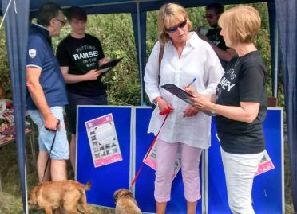
Photo 1: Promotions Officer, Ann Cuthbert, and a volunteer interviewing member of public

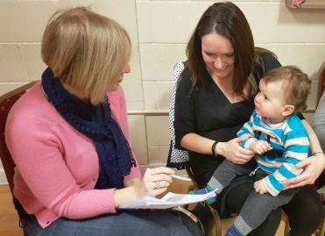
Photo 2: Promotions Officer, Ann Cuthbert, seeking feedback from a member of Ramsey's community

- Assessing the delivery of Specific Aim 1 - Creating and delivering a strategy for promoting heritage, business and tourism in Ramsey

  - Have the needs of local heritage & tourism business been understood and factored into the promotional strategy? Are they aware of the project and been given the opportunity to be involved?

    - Local Residents
Local residents’ opinions about what Ramsey needed were taken into account when the Promoting Ramsey project was devised. Before the project was commissioned, the Ramsey Million Partnership undertook public consultation with around 1,000 residents in 2012 in order to develop their community plan. 12% of the respondents felt that “something should be done to increase footfall in, what was perceived, as a declining high street” and 4.4% thought that “promoting Ramsey’s heritage would be a way to increase visitors to the area”.

    - Steering Group
Representatives from business, heritage, the community and the council attended Promoting Ramsey Steering Group meetings every two months and so have been consulted as to the promotional strategy and informed of its progress. The promotional strategy document was agreed before June 2015 ahead of the scheduled target. This strategy was re-evaluated and tweaked and agreed in consultation with the steering group in May 2016. The Steering Group were involved in focus groups, as well as presentations from the design agency, during the development of the brand and took part in the survey in June 2015 which was designed to ascertain how Ramsey saw itself and define the town’s ‘personality’ in order to inform the design brief.

    - Local Business
Businesses in Ramsey were consulted in several ways before the brand was designed: by personal visits from the Project Officer; by taking part in the Perception Survey and by being given an explanatory, illustrated leaflet, ‘The story of the brand’ (Appendix 4). All of this resulted in good buy-in from the retailers on the Great Whyte and High Street. When the brand was launched in September 2015 every shop, bar one, and every café, pub and heritage site hung the promotional bunting with the new logo in their windows or at the front of their premises. The council offices also hung bunting from their railings.

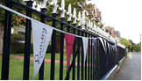
Photo 3: Promotional bunting hanging on council railings

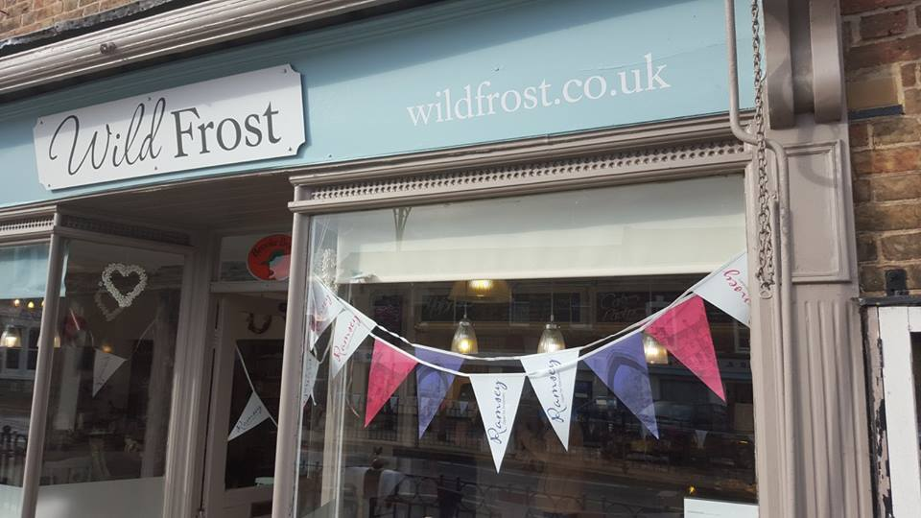
Photo 4: Shop displaying promotional bunting

“Discover Ramsey is high profile and getting the message out there – people in Huntingdon are asking ‘what is happening out there, tell me more about it? ‘ - and in a good way!”
Doug McIllwayne, Deputy Mayor, Ramsey and ex Huntingdon Town Councillor

Having listened to some retailers’ frustrations at the reduced footfall in town the Promoting Ramsey Project secured five articles in the local monthly newspapers focussing entirely on encouraging people to shop locally:
- “Shop locally at Christmas” x2
- “Father’s Day shopping in Ramsey”
- “High Street Health Check – how are we doing?”
- “Don’t let the roadworks stop you shopping locally”

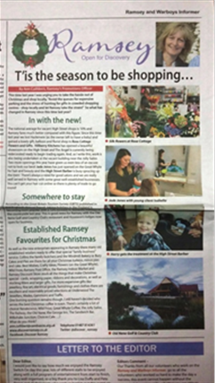
Photo 5: Christmas shopping article from local newspaper

“Hi, not sure if it’s your article or the sunny weather but the shop’s much busier!
Thank you so much for what you did.”
Claire, Best Wishes, card & balloon shop, Great Whyte, Ramsey

    - Heritage Attractions
Between May 2015 and July 2015, all the heritage attractions in Ramsey were visited by the Promotions Officer and made aware of the Promoting Ramsey Project. Site visits informed the project about the heritage sites and established relationships. All the heritage attractions were consulted on the website copy used, both about their own heritage sites and about the history of Ramsey.

All heritage attractions have continued to have visits from the Promotions Officer to ensure that communications remain open and both parties are aware of developments with the project.

“At last, a co-ordinated approach for projecting Ramsey’s heritage”
Robert Pickard, representing Lord De Ramsey’s estate on the Steering Group

“The Promoting Ramsey Project is the best thing that has happened in Ramsey for many years. We seem to be getting somewhere at last and are all working together. If there’s any way this project can continue it needs to be done”
David Cozens, The Lady Chapel

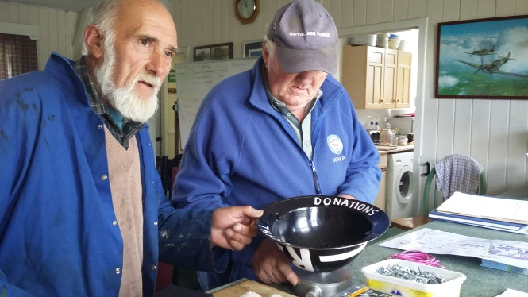
Photo 6: Meeting volunteers at the 1940s Camp

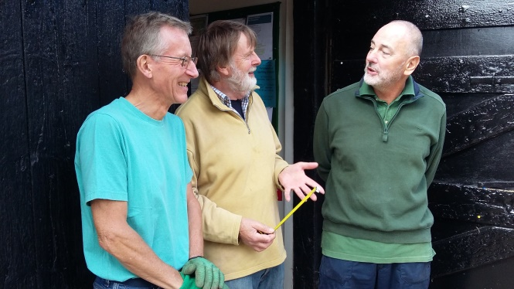
Photo 7: Meeting volunteers at the Ramsey Rural Museum

    - Awareness of Project
Overall in Ramsey, awareness of the Promoting Ramsey Project is high. Over 90% of those surveyed in November 2016 and in July 2017 had seen the branding before and 84% said that they knew about the Promoting Ramsey Project.

When the brand was launched in September 2015, every household in Ramsey received a leaflet ‘The story of a Brand’ and this, along with PVC banners in the town and the outlying villages, had an immediate impact.

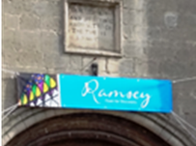
Photo 8: Promotional banner in place on Thomas a Becket Church on Abbey Green

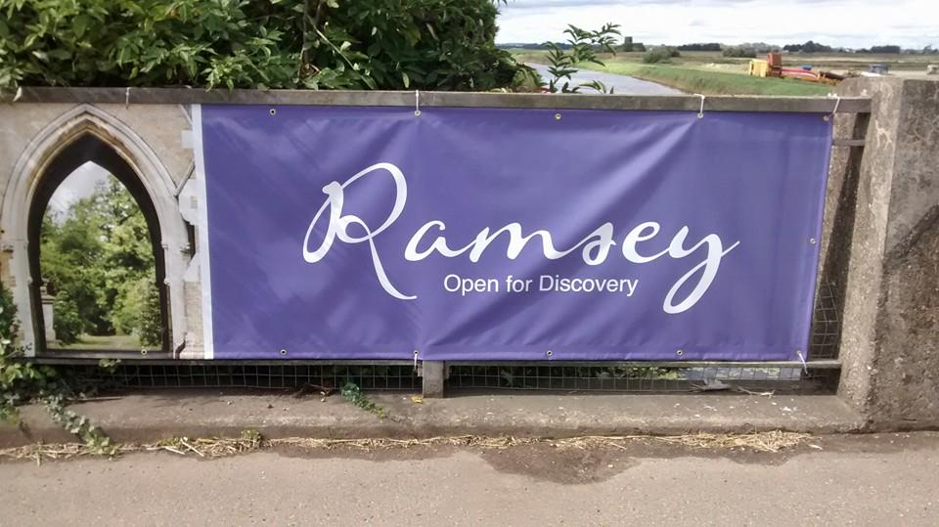
Photo 9: Promotional banner in place on Ramsey St Mary's Bridge

  - Do local people have a pride in Ramsey? Do people have a better understanding of what Ramsey has to offer them for leisure and retail? Are the website and social media are being used?

    - Local pride
Generally, people in Ramsey Parish have positive feelings about where they live, however, there has been improvement over the life of the Project. In the baseline survey of May 2015 when asked “On a scale of 1 to 10, with 1 being bad and 10 being excellent, how would you rate Ramsey as a place to live?” the 89 respondents who expressed an opinion scored Ramsey an average score of 7.3. When asked the same question in July 2017, the average score for Ramsey as a place to live had increased to 7.8 out of 10.

Of those surveyed in Autumn 2016, 81% of those over 18 and 53% of those under 18 felt that there was a more positive feeling in town compared with 2 years ago. In fact overall only 4% felt that there was a less positive feel to Ramsey compared with 2014. In July 2017, 88% of respondents felt that there was more going on in Ramsey than 2 years ago.

“I haven’t been to Ramsey for years – it’s had its rough edges knocked off!”
A visitor who called into the library

“Ramsey looks great, a real buzz to it. It’s so nice to come and visit.”
Sarah O’Brien, Pickering, Yorkshire

    - One single brand
The Promoting Ramsey Project has successfully introduced one single brand for Ramsey and this brand recognition is very high. In 2015 47% of those surveyed couldn’t think of any Ramsey brands and the highest score when prompted was the Facebook page for ‘Spotted in Ramsey’ which was recognised by 23%. Just 18% said they had seen the town council’s logo when shown a visual. By September 2016 the Discover Ramsey brand was recognised by 96% of respondents. The website was mentioned by 21% of respondents unprompted and 43% prompted.

Key statistics from Perception Survey [July 2017] relating to brand
Recognition of ‘Ramsey’ brand | Visited website | Visited Facebook page | Seen ‘Discover Ramsey’ in the magazines/papers
90% | 50% | 52% | 78%

    - Awareness levels of events
Eighteen months after the start of the project a significant majority of respondents were aware of events that Discover Ramsey had organised and promoted: heritage open days (83%), the Duck Race (83%), Craft Festival Street Market (83%), Gaiety Night (66%) and Treasure Island (45%).

    - Website and social media
The website and social media for the Project focus on “What’s On” with an events calendar online and regular tweets and Facebook posts about events in Ramsey and the surrounding area. The Discover Ramsey website was launched in November 2015 and by the end of September 2017 had received 55,084 page views and 605 page ‘likes’.

Discover Ramsey’s Facebook page has 626 followers and Twitter has 307 followers and has tweeted 532 times.

21% mentioned the website unprompted when asked about the Discover Ramsey brand in the 2016 survey and 43% said that they had seen the website, www.discoverramsey.co.uk, when asked directly. By June 2017, 50% of those surveyed had visited the website.

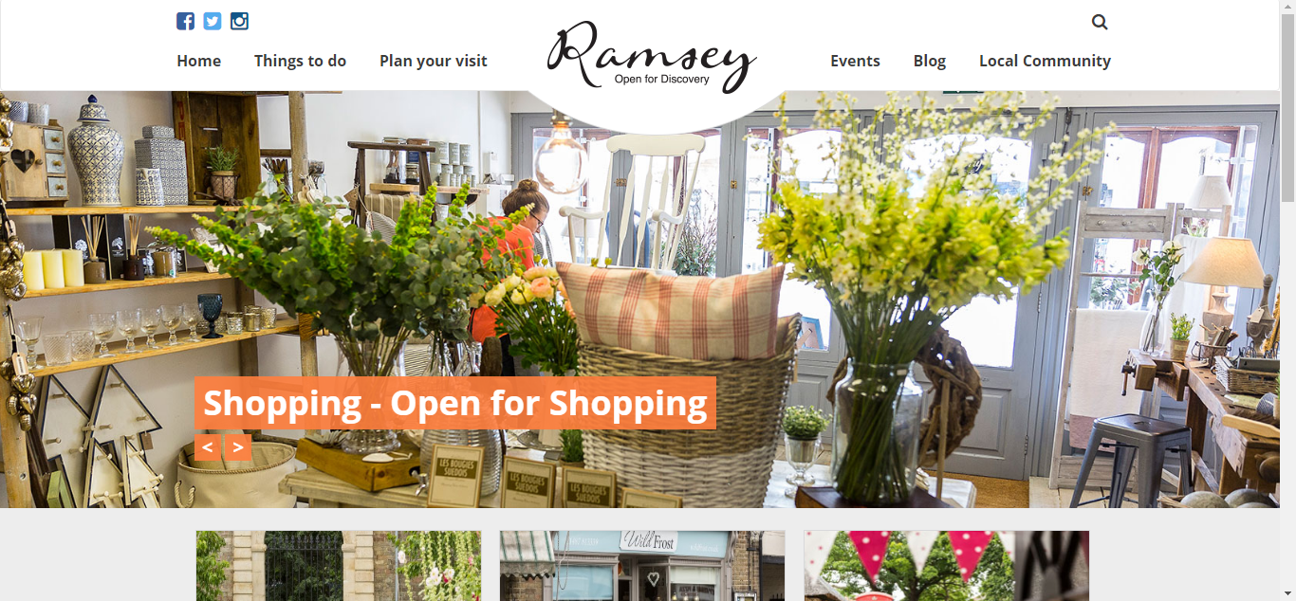
Photo 10: Screenshot of Discover Ramsey website

Figure 1: Website traffic over time

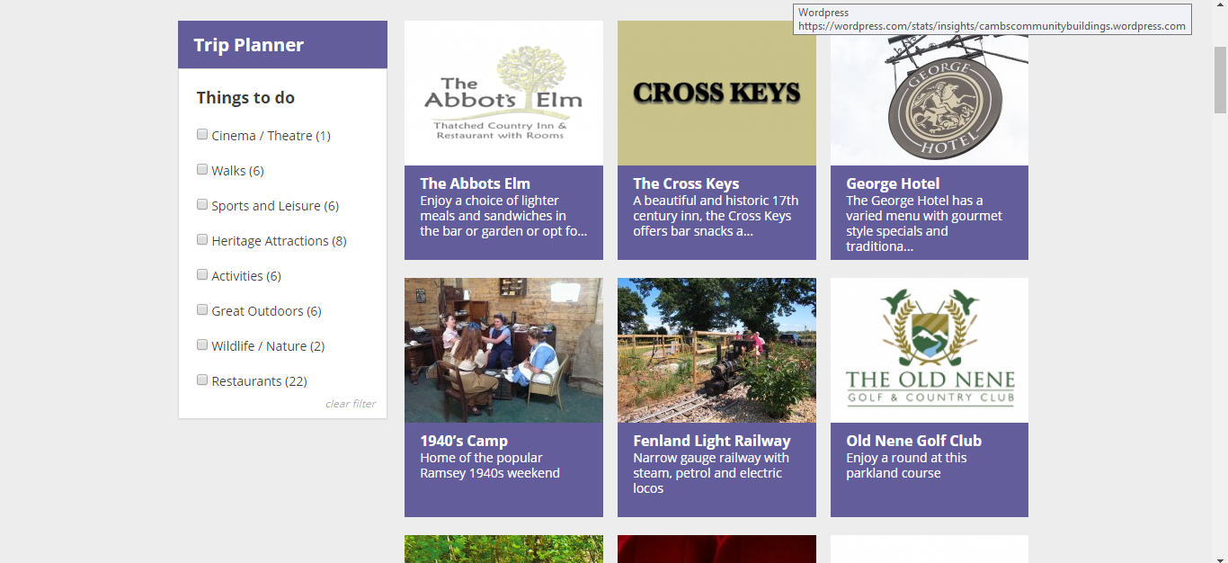
Photo 11: Trip planner element of Discover Ramsey website

“I can see so much has been happening in Ramsey, it is always popping up on Facebook, all good stuff. (The Project) is keeping Ramsey on the map and it is a beautiful town and it speaks for itself.”
Josie Leaford-Howe, The Fenland Trust

    - Other websites
In Spring 2015 Ramsey hardly featured on any other website. In an audit in May 2015, Ramsey town only appeared on two websites when two local bed and breakfasts mentioned the town. Once the brand and website were established then links to other websites started to materialise. Visit Cambridge, Abbey College, the Fenland Trust, Ramsey Town Council and the Great Fen all have links to www.discoverramsey.co.uk. Events have also appeared on Visit Britain (English Tourism Week), Visit Peterborough and English Heritage (National Heritage Open Day).

Trip Advisor had only two entries of any description about Ramsey in 2015 and by February 2017 had 20 entries: 4 things to do, 2 bed and breakfasts in Ramsey and 14 places to eat.

    - Press releases
The Promoting Ramsey Project has achieved a high level of coverage in local media. When asked about the brand in the November 2016 survey, 26% mentioned unprompted that they had seen the project in local newspapers. When prompted, 79% of adults and a quarter of 12-15 year olds had seen the Promoting Ramsey Project in the local papers and magazine.

When asked during the perception survey in July 2017 78% of respondents said that they had seen articles about Discover Ramsey in the press.

The number of press releases featured has averaged over five a month over the life of the project. Articles and photographs have appeared in the local monthly papers, the Ramsey Neighbourhood News magazine, the Hunts Post, the Cambs Times, the Peterborough Evening Telegraph and the glossy Cambs Magazine and the Fen magazine. In addition to this, the project has been featured on the Jeremy Sallis show on Radio Cambridgeshire and Hunts Community Radio.

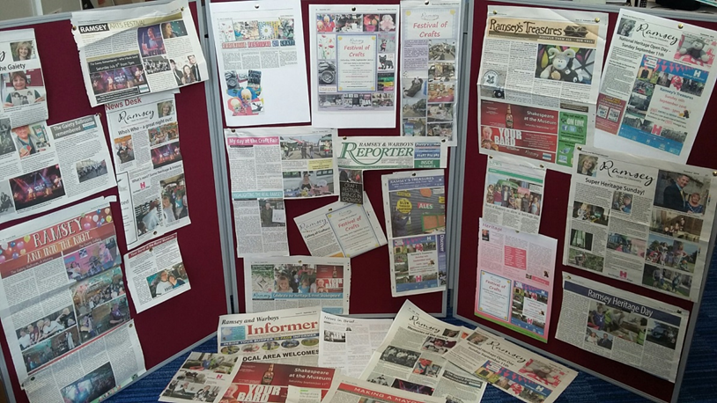
Photo 12: Press releases from July to September 2016

  - Are groups working better together? Are there more joint events being delivered?

    - Heritage Group Meetings
Heritage Group Meetings are held regularly and all heritage groups send at least one participant. Ramsey Town Council also attends and supports joint heritage events. Since the project started there have been three National Heritage Open Days (September 2015, 2016 and 2017) plus 2 additional Spring Heritage Discovery Days with a Duck Race in April 2016 and a Journey through Time in April 2017. The latter featured the Old Nene Golf and Country Club who hosted some family activities with a medieval theme. The Club, which has a new club house/venue, has 7 Hoseasons log cabins and worked with the heritage open day to develop their tourism offer.

The heritage days have resulted in record numbers at many of the sites and the sites have all worked together with joint themes and competitions that encourage visitors to visit multiple sites.

“It was a record day for us, nearly twice as many visitors as last year.
They think that Ramsey is wonderful and will come again”
Jane Yardley, Chair, The Mortuary Chapels.

“After a disappointing rainy day yesterday in Houghton Mill it was a relief to see so many people enjoying the sunshine and heritage in Ramsey.
Last year we had 300 visitors and today we had 481”
Phil Donaghue, NT Abbey Gatehouse

New heritage attractions have come on board for heritage day such as the Abbey House, which has put on an exhibition of school archives and photos in the library, and also the Scout Group, who opened their scout hut sharing its history as the old fire station.

25% of adults surveyed in November 2016 had attended a heritage open day in Ramsey. (See 4.1 for attendance figures)

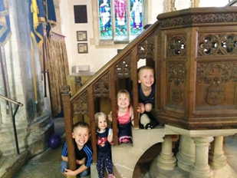
Photo 13: Children enjoying a heritage open day

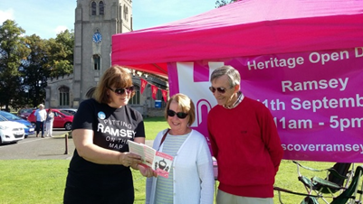
Photo 14: A volunteer with visitors at a National Heritage Open Day event in Ramsey

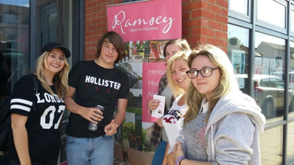
Photo 15: Local teenagers set off from the library on a heritage open day

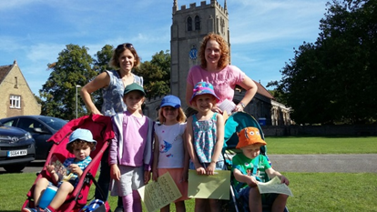
Photo 16: Families enjoying a Heritage Open Day

    - Arts Groups
The project has worked with arts groups in Ramsey to produce shows at the 1940s camp and the Rural Museum:

      - Create Fest - July 2015 and July 2017
Discover Ramsey supported this bi-annual Ramsey Million free music festival over the two years. 700 attended the first event and over 2,000 attended the second which was extended to a day and evening festival with bands playing until 10pm.

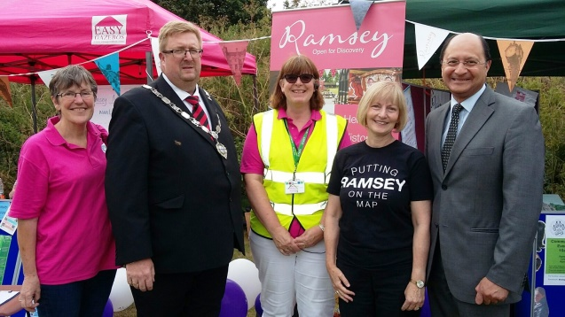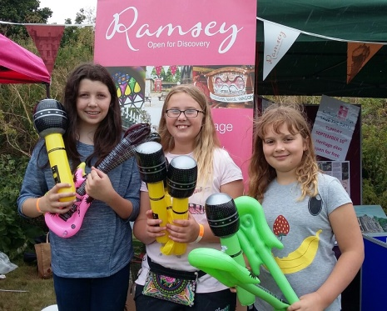
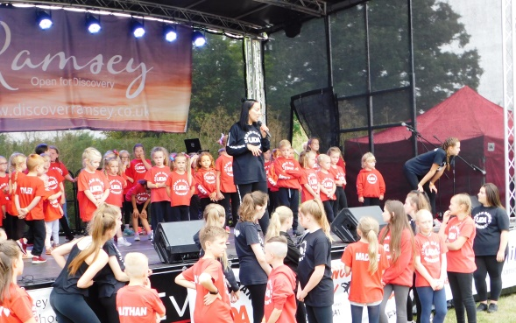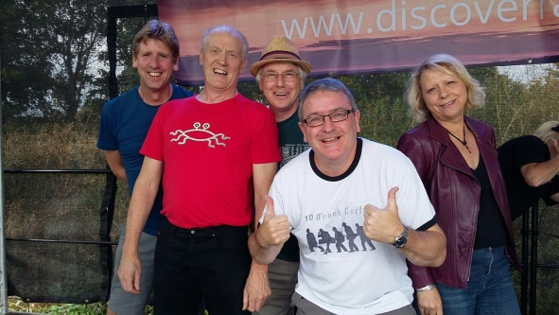

      - Gaiety 1960s event – 9 July2016
The ‘Bring Back the Gaiety’ event was a joint venture with the Ramsey Arts Festival who shared the costs of the event. It was a sell out with 200 attending, two bands played, fish and chips were served and an exhibition was held for Ramsey’s old Gaiety days when the nightclub prospered in the town. Articles in the press in the months before the event asked for stories and memories of the Gaiety and resulted in an exhibition in the library and at the event as well as features in the newspapers. There was extensive local press coverage and good community engagement with the history of the Gaiety.

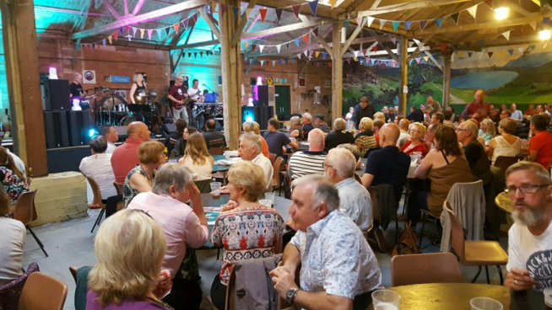
Photo 17: A packed house for “Bring back the Gaiety” night

      - Shakespeare’s 400th anniversary event - 17 September 2016
Nicholas Collet, fresh from the Edinburgh Fringe, came to Ramsey with his one man show, ‘You’re Bard’. The Promoting Ramsey Project supported Ramsey Arts Festival who hosted this event with a hog roast in the barn at the rural museum.

      - Two Craft Festivals
Saturday events in Great Whyte (Craft Street Festival) 24 September 2016 and 23 September 2017. The street craft market was fully booked with over 30 stalls for both years and the town was buzzing. Cafes reported busiest ever day’s trading and the baker stayed open beyond closing time as trade was so busy. There was an excellent reaction from people who came to the town and on Ramsey’s various Facebook sites.

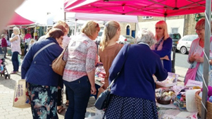
Photo 18: Craft Market

“I have been doing regular Saturday markets for 3 years in this area and today was my most profitable yet”
JD Eaton, Stallholder

“It really is an ideal situation today and what we need is for people to come into Ramsey, see that it is thriving and that people are happy and really enjoying a Saturday in old England”
Pat Taylor, former Mayor, Ramsey

“It’s nice to see everyone stopping and talking.”
Craft Festival visitor

“How wonderful that people are staying, usually people just nip in and out.”
Craft Festival visitor

Today has been the busiest day ever in the history of Wildfrost cafe! Thank you to my fabulous staff (Maria and Maureen) and my wonderful customers. Also a huge thank you to Ann Cuthbert and her team for organising a wonderful festival of crafts in Ramsey town today
Wildfrost Café Facebook page- 24 September 2016

When the event was repeated in 2017 there was a similarly positive response and, despite a cold day, the town enjoyed its busiest day of the year to date. Retailers utilised the space in front of their shop to put on craft workshops and the fish and chip shop is planning to put out tables and chairs on the street next time.

Ramsey festival of Crafts was a good day. Lots of amazing local crafts were on show. We set up a workshop outside giving folks an opportunity to use the chalk paints for free. Some people went to the local hospital charity shop to buy glass and ceramic pots to paint. We also had some wooden butterflies to paint and frames. Harry had painted a glass pot for his mums Cactus and Amelia painted a beautiful butterfly for her bedroom.
Simply Snugg Home Décor Facebook page

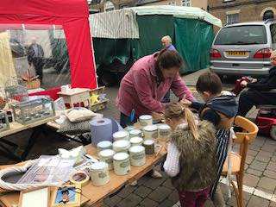
Photo 19: Local retailer joins the Craft Festival

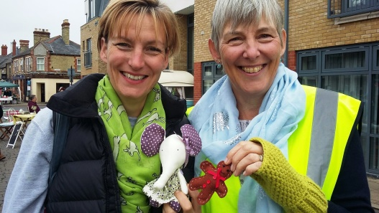
Photo 20: Happy with their purchases: a local resident and a volunteer

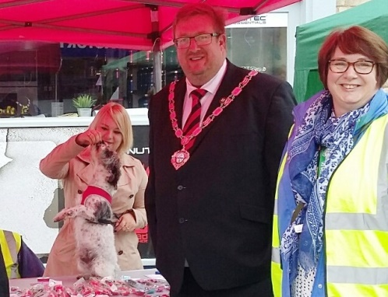
Photo 21: Ramsey Mayor, Doug McIlwain at the craft festival with a volunteer

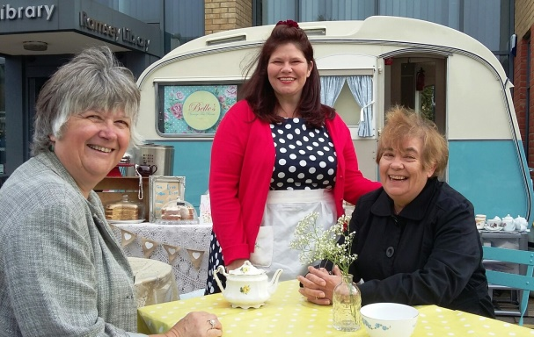
Photo 22: Deputy Mayor, Adela Costello, supporting Belle’s Vintage Tea Room with local retailer Karen Gammons

      - Treasure Island – 9 December 2016
Christmas saw Treasure Island, a family show at the Drill Hall on the 1940s Camp. Affordably priced for anyone in Ramsey at £16 for a ticket for 5, there was an audience of 120 despite the 4 week lead time.

“We loved Ramsey and it was definitely one of our favourites for the show- the audience was so engaging and vibrant and that made the show. We cannot wait to come back.”
Tom Fox, Lamphouse Theatre

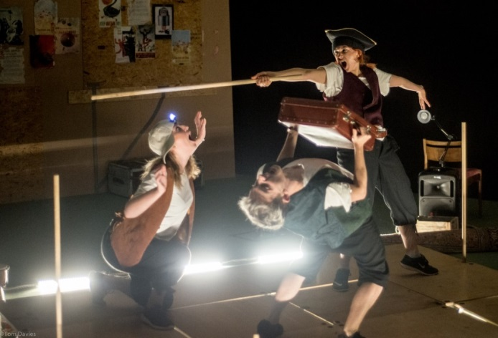
Photo 23: Theatre production of Treasure Island

    - Partnerships outside Ramsey
As well as Ramsey’s heritage attractions, the Project has also worked with partners from outside Ramsey to attract tourists to visit:

      - Driving Trail
Working with Peterborough Cathedral, the Fen Edge Trail, the Fenland Trust, Yaxley and the Great Fen, the Promoting Ramsey Project devised a driving trail in October 2016. The trail is one of a series of Ramsey trail leaflets and is also downloadable from the website. Peterborough Tourist Office hosted a window display featuring the new Driving Trail in October 2016 and in the spring 2017 and the 300 leaflets that were left there had all been taken by the end of January. Peterborough Cathedral information and education centre took 200 leaflets which had all gone by February 2017.

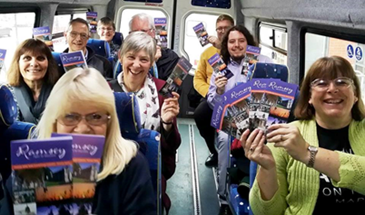
Photo 24: Invited heritage volunteers & press on community bus enjoying the inaugural Driving Trail

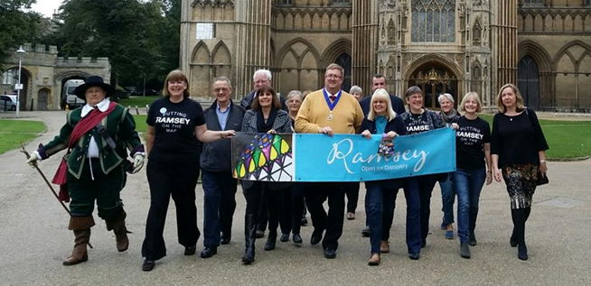
Photo 25: Ramsey Mayor, Doug McIlwain and others take the first steps at Peterborough Cathedral

“It was a fantastic tour which highlighted some of the many attractions that Ramsey has to offer. My congratulations to the Promoting Ramsey Project and all the other groups involved in this endeavour”
Doug McIllwayne, Deputy Mayor

“When Ramsey announced that they were going to do this driving trail we wanted to be part of it. We are very grateful that Yaxley has been allocated a spot on the trail.”
Stewart Howe, The Fenland Trust

      - Childrens’ Activity Pack
Ramsey Neighbourhoods Trust, with funding from Cambridgeshire Family Learning Fund, funded the design and production of this Discover Ramsey resource. The nine page pack comes with a pack of pencils and is available in the library and the church on the Abbey Green. It features Rammy the Ram and is full of activities that can be done even if the heritage sites are closed. It also encourages return visits and signposts families to the website.

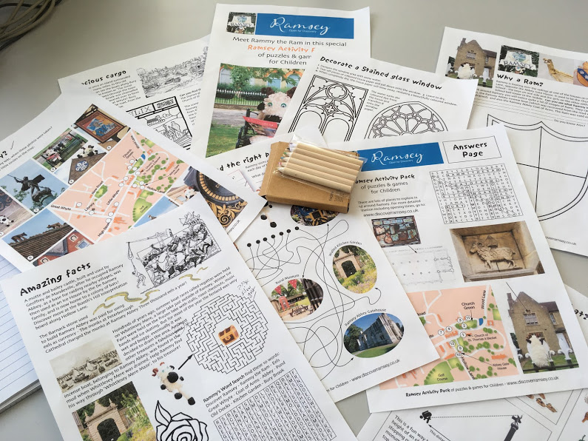
Photo 26: Children’s' Activity Pack

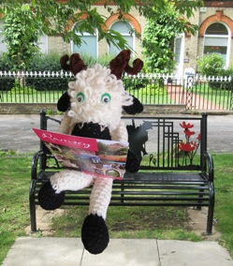
Photo 27: Rammy the Ram

- Assessing the delivery of Specific Aim 2 - To make Ramsey’s heritage and tourism offer more appealing to visitors

  - Are Ramsey’s heritage and tourism attractions being better used?

    - Heritage sites more visited
Perception surveys carried out at the beginning and the end of the project show a marked increase in visitor numbers to Ramsey’s heritage sites.

% who have visited | 2015 | 2017
Ramsey Rural Museum | 59 | 82
Great Fen | 41 | 71
Church | 59 | 80
1940s Camp | 60 | 90
Lady Chapel | 27 | 49
Mortuary Chapels | 25 | 49
Walled Garden | 42 | 61
Fenland Light Railway | 29 | 53

    - National Heritage Open Days, September 2015, 2016 and 2017
Heritage Open Days have recorded excellent numbers and the number of heritage open days has increased from 1 to 2 per annum. Visitor numbers for the September National Heritage Open Days have increased from 2015. The weather was glorious in 2015 and 2016 but was cold, dull and wet in 2017. The increase in numbers was an excellent result and improved marketing and co-operative working among the heritage sites made a huge contribution to the day’s success. Not all heritage attractions are able to count the visitors consistently as they are relying on volunteers on what is a busy day.

 | 2015 | 2016 | 2017
Library | 122 | 150 | Not recorded
Gatehouse | 300 | 481 | c. 400
Mortuary Chapels | 179 | 323 | 328
Walled Kitchen Garden | 350 | 475 | 479
Ramsey Rural Museum | Not recorded | 450 | 650

The first 2 National Heritage Open Days were very busy from 11am right through until 4pm as was witnessed by the 29 seater vintage bus being full on every trip around the sites and the St Thomas a Becket Tower Tours being fully booked throughout the day. In 2017 a much larger vintage bus was hired and the day was lengthened to 5pm.
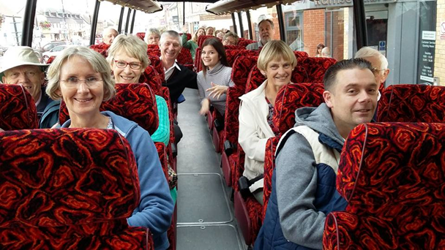
Photo 28: Vintage bus tour

“The heritage day was really well planned. My 6 and 3 year olds loved hunting around for the hidden rams and learning about the Ramsey heritage. The family fun events at the golf club were great – we will definitely be attending the next event”

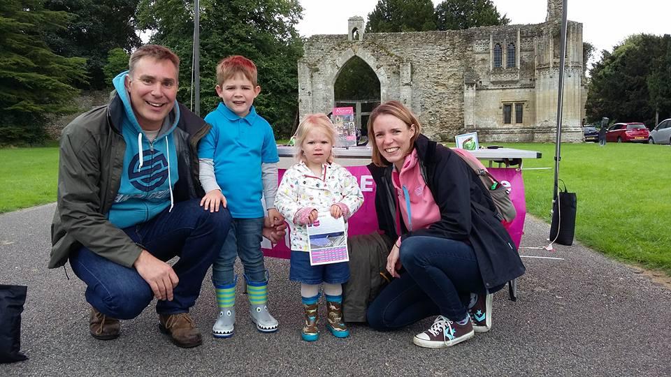
Photo 29: Setting off to find the “rammies” on a heritage day

As a family of four (children aged 7 and 5) living in Ramsey we have really enjoyed the various heitage events that have taken place over the last year or so.It’s great to be able to come along and enjoy events as a family and to learn about our community.”

    - Visitors from outside Ramsey
The Rural Museum and the Mortuary Chapels have visitor books and reported that the postcodes recorded at the September 2016 National Heritage Open Day were the most varied that they had seen at their attractions indicating that people were visiting from further afield. On the day, the Project Officer spoke to people from Cambridge, Nottingham, Birmingham, Bedford, London, Huntingdon and March.

“I have been looking for a contact in connection with yesterday's (11 Sep) heritage day and hope that you can forward this to the right person. I would like to say what a wonderful day my family and I had on our first visit to Ramsey. The whole event was very well organised and we enjoyed every aspect of it and exploring Ramsey. Everyone involved was so polite, informative and helpful including the school children. We hope to visit again soon. Thanks again.”
Bernice Monk, Bedford

“What a pleasure it is to come to Ramsey on a day like today when the town is celebrating its history and heritage. I’m very impressed that so many are involved and it shows how proud people are of where they live.”
Sebastian Kindersley, Chair of Cambridgeshire County Council

At other times of the year visitors having coming from outside Ramsey.

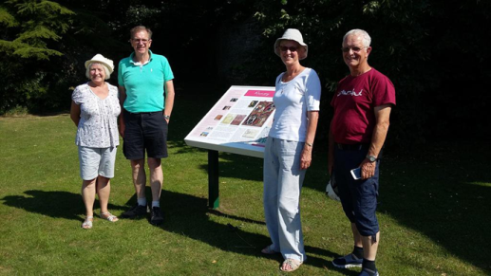
Photo 30: These visitors from Suffolk saw the website and decided to take friends to Ramsey for the day in October 2016

“There’s so much to do here, the High Street looks good. We’ll come back when there’s something on in Ramsey”
Visitors from Cambridge at the 1940s weekend

The Rendezvous Café has also noticed extra visitors including cycle clubs from Peterborough, Yaxley and Cambridge who now call in for breakfast on their days out.

    - Special Heritage Sundays April 2016 and 2017
An estimated 500 people watched the duck race and over 300 people were recorded entering the library (which served as the hub for the day). Heritage attractions reported a significant increase in visitor numbers compared with a normal Sunday when they open. As well as an increase in visitors there were 20 volunteers working on the day plus those in the heritage sites.

The Duck Race provided good material for social media and, among the various tweets and posts, one particular image on a free post on Facebook recorded over 2,000 hits and a Mumsnet post reached 1,300 hits.

“A quacking good day out for the Discover Ramsey Duck Race - Hundreds of bright yellow ducks adorned the Ramsey waters at the weekend…spectators enjoyed a lovely day out by the river in glorious sunshine whilst finding out about the heritage Ramsey has to offer.”
Peterborough Evening Telegraph

“The real success of the day came from the heritage sites, which were promoted extensively during the afternoon, although local business was also booming, with one shop owner describing the day as the busiest Sunday he had ever seen.”
Ramsey & Warboys Reporter

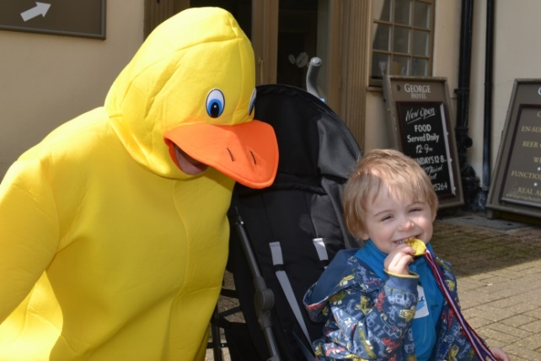
Photo 31: A young visitor makes friends at the Duck Race on heritage day

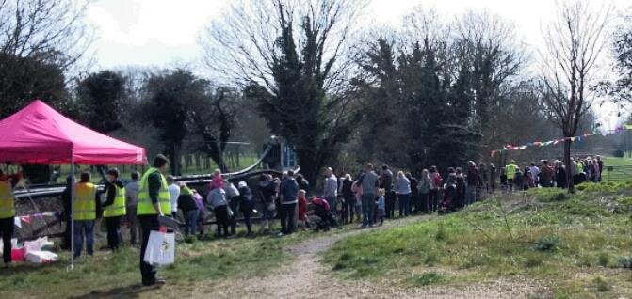
Photo 32: Participants in the Duck Race

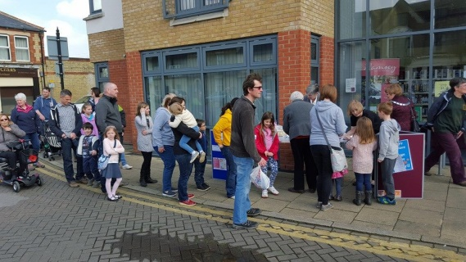
Photo 33: Visitors on Duck Race Day queueing for their ducks at the library

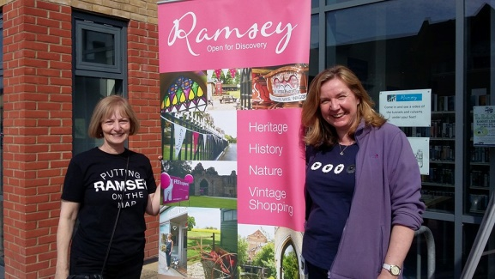
Photo 34: Promotions Office, Ann Cuthbert, and Cambridgeshire ACRE’s Community Development Manager, Rachael Brown, promoting the event

In April 2017 Ramsey experienced a Journey through Time with each site focussing on a different period of history. 351 visited the Mortuary Chapels and over 400 came to the museum. The Old Nene Golf Club who staged re-enactors, games, archers and burgers experienced their busiest-ever day.

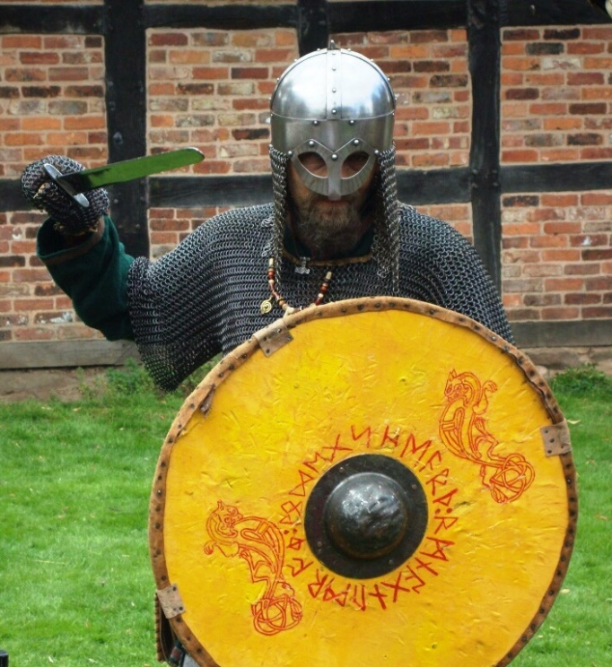
Photo 35: A re-enactor for a Journey through Time

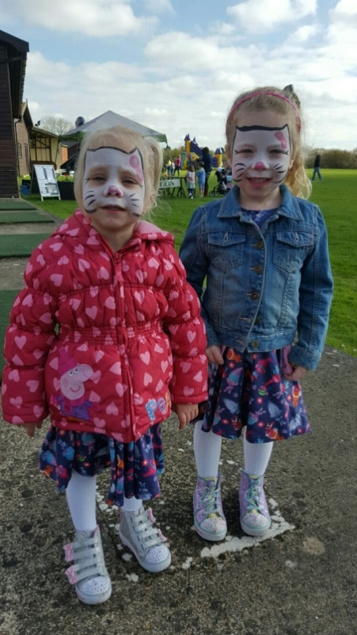
Photo 36: Two girls enjoying face-painting

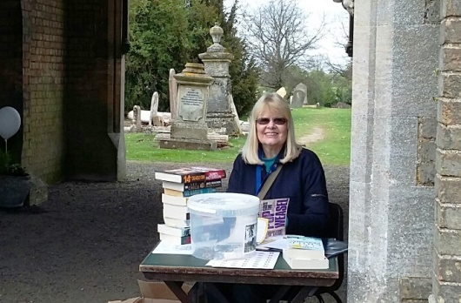
Photo 37: Jane Yardley, Chair of the Mortuary Chapels, ready for visitors on a heritage day

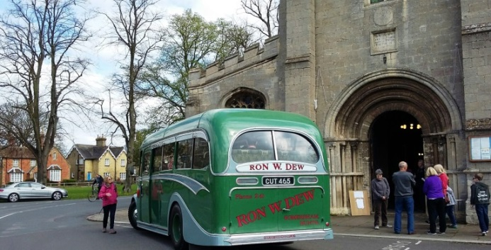
Photo 38: Vintage bus

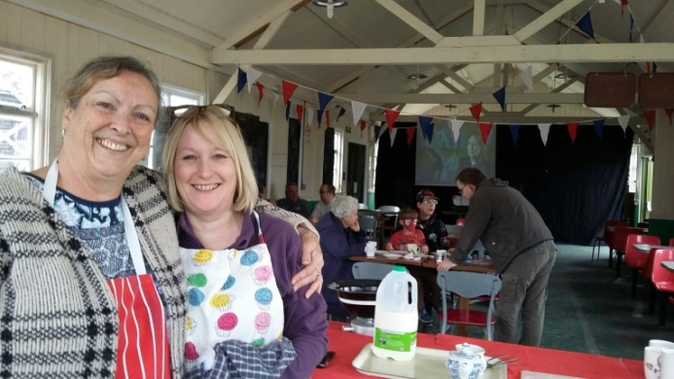
Photo 39: Volunteers at the NAAFI at the 1940s Camp on a heritage day

    - Expansion of uses for heritage sites
Since the beginning of the Project, two heritage sites have started hiring out their sites as a venue much more and another heritage site is considering how they could do the same. The 1940s Camp needs more revenue than the 1940s weekend can provide and have begun hosting parties and weddings in their Drill Hall. In fact the Drill Hall is virtually fully booked every Saturday night in 2018 at the time of writing (October 2017). The Rural Museum has followed a similar path and also hosted their first wedding in 2016 and the Walled Kitchen Garden is looking to hire out the glasshouse and garden for small events.

- Assessing the delivery of Specific Aim 2 - To increase individual and community capacity for taking forward own ideas for revitalising Ramsey

  - Are Individuals and community groups involved in a meaningful way in partnership with each other?

    - Steering Groups Meetings
The Promoting Ramsey Steering Group meet every two months. Membership/attendance is between 14 and 17 representatives drawn from business, tourism, council, community and heritage groups. This group has been instrumental in steering the branding, website, promotion and joint events on which the Promoting Ramsey Project has worked.

    - Heritage Group Meetings
Regular Heritage Group meetings, where joint events are put together, ideas are shared and strategies are planned have been well attended and valued by participants. When asked during the November 2016 survey, 100% of the heritage sites valued the heritage meetings with 83% saying that they valued the meetings. “very much”.

“It is very important that heritage groups, and all community groups, work together. In the past there were many active groups but they weren’t in contact with each other – this has changed for the better.”
David Cozens, National Trust volunteer

“Joint projects like the Driving Trail have been really good for us. Working together we become part of a bigger attraction. It’s good to keep in the loop with other heritage groups as we can achieve more together as a large group. For us linking up with heritage brings a new audience that isn’t just wildlife focussed.”
Louise Rackham, Education and Community Manager, The Great Fen

“You no longer feel alone working to make Ramsey better. You feel there’s back up and someone co-ordinating all the heritage efforts.”
Jane Yardley, Mortuary Chapels

“The Promoting Ramsey Project has made a huge difference and has had a much greater impact than other schemes there have been in the past. People are working together and getting things done.”
Jane Sills, The Walled Kitchen Garden

“This is the first time things are coming to fruition. The National Trust will be producing their materials in the same style and will be using your Ramsey brand and artwork for the National Trust information board being produced for the Abbey Green outside the Gate House.”
Phil O’Donaghue, National Trust

    - Exhibitions
Attendance at appropriate exhibitions brought the heritage and attractiveness of Ramsey to more potential visitors. The Promoting Ramsey Project attended the Great Fen Discovery Days at the Countryside Classroom and Holmewood Hall, the Yaxley Festival weekend, Ramsey Carnival, the Mayor’s Service, Ramsey library, Ramsey Rural Museum, the 1940s weekend, and the Great Fen Lego build at Hinchingbrooke Park.

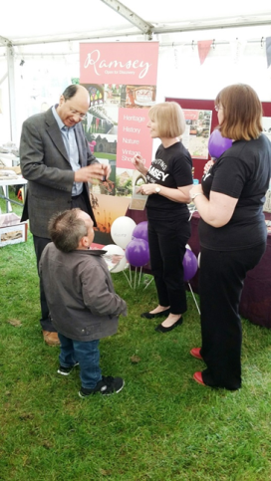
Photo 40: Showcasing Ramsey at the Yaxley Festival Summer 2016 with Shailesh Vara MP and Warwick Davies

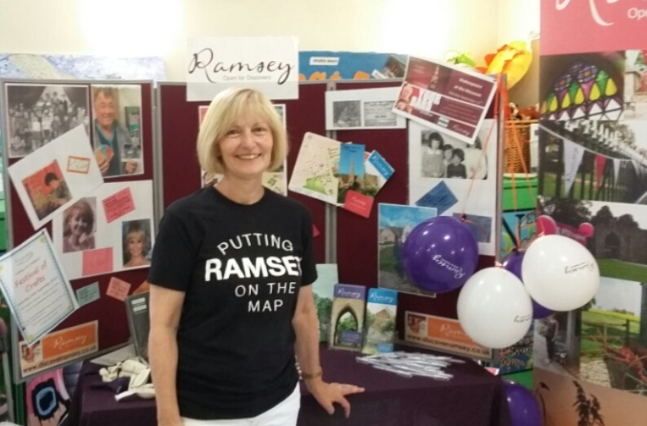
Photo 41: Promotions Officer, Ann Cuthbert, manning the Promoting Ramsey stall at an event

  - Are volunteers gaining skills in destination marketing and promotions?

    - Visitor Information Points
Retail, tourist, heritage venues and the library in Ramsey have become Visitor Information Points (VIPs) and they have stickers on their windows so that visitors to the town know that they can go into the shop/venue and pick up a free visitor information pack.

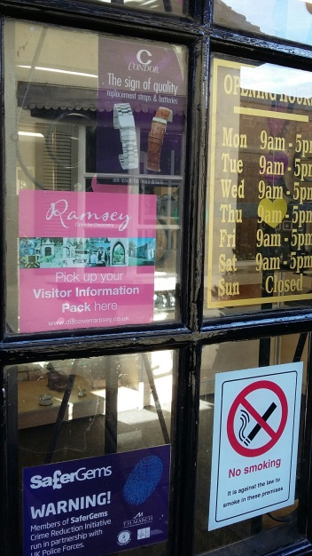
Photo 42: Visitor Information Point sticker in window

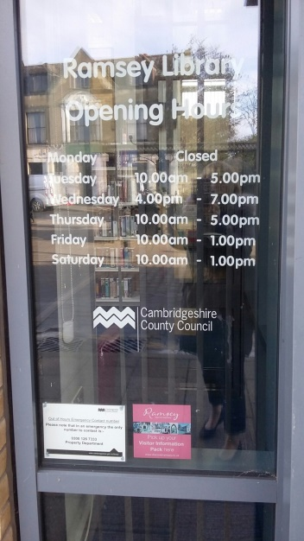
Photo 43: Visitor Information Point sticker at Ramsey Library

The Visitor Information Packs contain information on the four Ramsey trails and the Peterborough to Ramsey driving trail. They also contain leaflets for the Rural Museum, the Walled Garden, the Mortuary Chapels and the Great Fen.
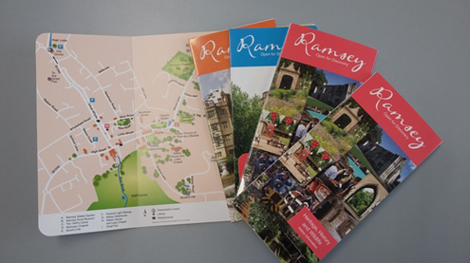
Photo 44: The Visitor Information Pack with the Ramsey Trails leaflets

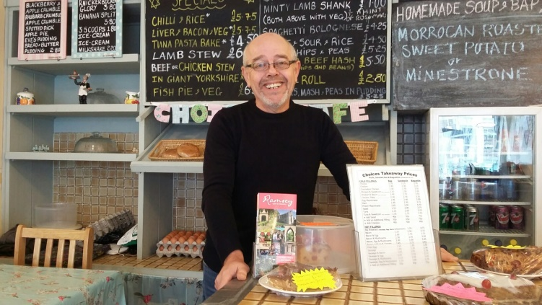
Photo 45: VIP volunteer at Choices café with visitor information packs

The George Hotel, the campsite and the Hoseasons lodges are VIPs. Ten retailers in town, the library and all the heritage sites have the window sticker showing that they are Visitor Information Points. At the heritage sites, in addition to the visitor information packs, there are also A3 or A4 poster displayed with a map and few words about all the nine heritage sites to encourage multiple visits in Ramsey by visitors.

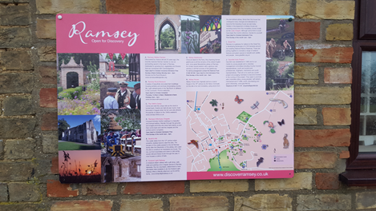
Photo 46: Panel used at heritage sites including the Great Fen
  - Do volunteers feel confident promoting Ramsey with those they come into contact with?

    - Volunteers at events
At the events co-ordinated and promoted by the Project, volunteers are briefed on the heritage sites and are confident to offer advice both about the heritage in Ramsey and to signpost visitors on their way.

    - Volunteers at Visitor Information Points
Volunteers at VIPs are confident in signposting visitors to the information packs and are happy to give advice on where places are in Ramsey. The retailers in particular, take an interest in the visitors to the town and have observed increased numbers over the past year.

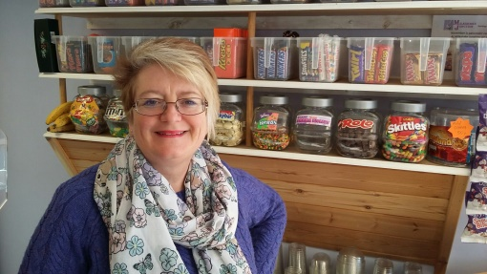
Photo 47: Visitor Information Point at Milkshake Junction

“People are coming here from Peterborough and other places. I’ve noticed it this past week with lots of kids on half term coming from Peterborough and Hampton. Our kids are back at school as the holidays are different.”
Claire, Milkshake Junction

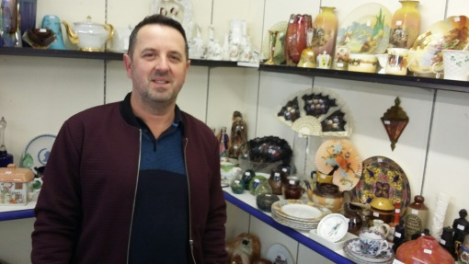
Photo 48: Visitor Information Point at Antiques and Collectables Stall

“I think we’re definitely getting more people from further afield – we’ve had people visiting for the first time from Bedfordshire, Derbyshire, Peterborough”
Clifford Horn, Antiques & Collectibles, Indoor Market, High Street

- What could have been done differently and other influencing factors

  - What could have been done differently

    - Re-profiling of the project
Although the project has largely met its objectives the Steering Group agreed that adding an extra six months (with reduced hours from the Project Officer) would give more time for the brand and website to become established.

The Ambassador Scheme was also re-profiled to be more realistic and effective. Town ambassadors would have been very hard to recruit and would have been needed to be available and accessible 7 days a week. Re-profiling this to a Visitor Information Point (VIP) Scheme made use of many outlets open during working hours and so ensured that visitors would be able to access the Visitor Information Packs at 20 locations around the town and heritage sites.

    - Media coverage further afield
Although the press coverage is well established in Ramsey and has extended to Huntingdon and Peterborough and Whittlesey more time needs to be spent working on articles in outlying towns such as March, Stamford, Ely and Chatteris..

    - More involvement of local business
Heritage events bring visitors to the town but are usually held on a Sunday when almost all the retailers are shut. More town events need to be held on Saturdays.

  - Key factors for success

    - A local project officer
Employing a project officer with existing connections to the local community was beneficial in several ways. Firstly the work was trusted by the community as it was being carried out by ‘one of them’ and secondly the project hit the ground running as the project officer was already known in schools, community groups, arts groups and businesses in the area. It was important that the project officer cared about the town and, in addition, as a local, she felt that her reputation was on the line living in the town she was promoting.

“Having a skilled, local person with connections to many community groups in Ramsey meant that this Project hit the ground running and has achieved even more than we hoped for.”
Annie Wells, Vice Chair Ramsey Million

    - Team working
Sharing an office with Ramsey Neighbourhood Trust and Ramsey Million Partnership and the Phoenix Project has led to joined-up community working that has given the Promoting Ramsey Project many advantages. The local community and heritage groups were also very supportive of the project. The town council and the retailers embraced the brand and the visitor packs and were co-operative when the packs were launched and placed.

6.2.3.Big Local

“This project and its outcomes has implications for other communities. This approach has worked and we believe it could be replicated in other Big Local areas.”
Nicky Stevenson, Big Local

6.2.4. Strength of the brand
Having a strong, professional brand, widely promoted and flexible in its uses meant that it was freely adopted by the town and the heritage sites. The brand was strong because of the thorough consultation and research which fed into the brief for the design agency.

6.2.5. A wide range of events
Having a wide range of events meant that different audiences were engaged bringing the project to a good number in the area. Various events were held at different times of the year so that publicity continued year round to keep brand awareness building.

6.2.6 Heritage Groups and Business working together
Businesses worked with the project on heritage days and became involved in the street market. Shops opened on Sundays for heritage day, some offered discount vouchers at the street craft festival to encourage shoppers in and retailers and eateries used the areas in front of their shops to gain a presence in the street during the festival.
During the April heritage day the Golf and Country Club joined in with gusto, employing re-enactors, engaging the archery club to hold taster sessions, hiring a bouncy castle and putting on a barbeque for visitors.
Working with the Project, heritage groups and businesses were happy to take advantage of the mutual benefits of contributing towards a good day for visitors to Ramsey.

6.2.7. Wide promotion
Although local audiences made up the lion share of visitors to Ramsey the number of people travelling in from further afield increased in line with the efforts to promote the town to a wider audience. As well as joining the websites in neighbouring tourist hotspots such as Cambridge and Peterborough, the Project also worked to get more mentions of Ramsey attractions generally n the web.
Press releases featured in newspapers and magazines in Peterbourough, Huntingdon and Whittlesey pushing the visitor message out into Fenland and the larger towns.
Social media was used extensively to link up with groups outside Ramsey such as Mumsnet, Cambs for example.
Discover Ramsey information packs were used widely in tourist information offices, campsites, hotels and attractions outside of Ramsey to draw in visitors.

6.2.8 Budget
At all times during the Project was delivered within budget. At the end of the Project Discover Ramsey Information packs were re-ordered to ensure that the momentum can continue in the town and that the retailers and library can continue as information points for visitors.

Appendix 1: Perception Survey conducted June 2015

On a scale of 1 to 10, with 1 being very bad and 10 being excellent, how would you rate Ramsey as a place to live?

Would you recommend Ramsey as a place to visit? | Yes or No

Can you name any reasons why anyone would come to visit Ramsey?

Have you ever been to any of the following? | Yes or No
Ramsey Rural Museum
The Great Fen
Thomas a Becket Church
The 1940s Camp
The Lady Chapel
The Mortuary Chapel
Ramsey Walled Garden
The Marina
Fenland Light Railway

Would you recommend anyone to visit any of the following? | Yes or No
Ramsey Rural Museum
The Great Fen
Thomas a Becket Church
The 1940s Camp
The Lady Chapel
The Mortuary Chapel
Ramsey Walled Garden

How do you know what is going on in Ramsey?

Do you know what the phrase “Ramsey Parish” means?

In your opinion what term best describes Ramsey and the four Ramsey villages? | Tick one or two here
Market Town
Fenland Market Town
Historic Market Town
Ramsey Parish
Market Town on the edge of the Fens
The five Ramseys
Ramsey of the Fens
Historic Fenland Town
Ramsey, Cambs

And finally, can you describe any logos, websites or face book pages associated with Ramsey?

Have you seen any of these before? | Yes or No
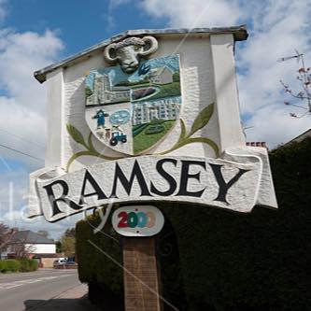Spotted in Ramsey Cambs
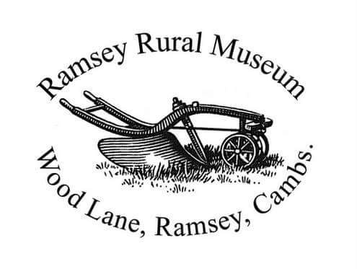
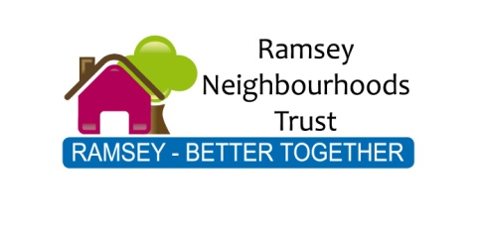
Ramsey Abbey Walled Kitchen Garden
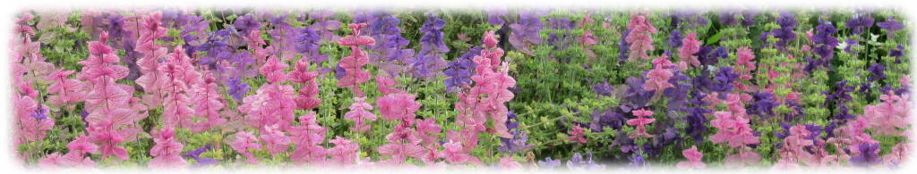

Appendix 2: General Questionnaire conducted November 2016

Name:
Date:
Organisation:

- Can you tell me anything about it? | Yes/No

The new branding is in fact the work of the Promoting Ramsey Project which is a 2 year project funded by the Ramsey Million. The main aim of the project is to promote heritage and tourism (and therefore business) in Ramsey and to create special events to celebrate the town’s local distinctiveness and heritage.

- Have you seen anything about the Promoting Ramsey Project on any of the following? | Yes/No | With prompts
Reporter or Informer newspapers
Ramsey Neighbourhood News
Hunts Post or other newspapers
Discover Ramsey website
Discover Ramsey Face book page
Discover Ramsey twitter
Ramsey Million Face book page
- Have you heard of any of the following in Ramsey? | Tick here | Attended
Heritage Open Days
Re-live the Gaiety Night – (Who’s Who Concert)
Duck Race
Craft Festival Street Market
Ramsey Million
Create Fest
Christmas Lights Switch On
Treasure Island

- Do you think there is a more positive feeling in the town compared with a few years ago? If “Yes” how?

- Have you noticed extra visitor numbers in the town? If “Yes” when?

- Do you think having someone employed in a Promoting Ramsey role makes a difference?

Appendix 3: Perception Survey conducted July 2017

On a scale of 1 to 10, with 1 being very bad and 10 being excellent, how would you rate Ramsey as a place to live?

Would you recommend Ramsey as a place to visit? | Yes or No

Have you ever been to any of the following? | Yes or No
Ramsey Rural Museum
The Great Fen
Thomas a Becket Church
The 1940s Camp
The Lady Chapel
The Mortuary Chapel
Ramsey Walled Garden
Fenland Light Railway

Have you see the Discover Ramsey brand before?
Website or Facebook | (specify)
In the newspapers

And finally, do you think there is more going on in Ramsey over the past 2 or3 years?

Name:

Do you live locally?

Appendix 4: ‘The story of a brand leaflet

Appendix 5: List of resources

1.Downloadable leaflets

http://www.discoverramsey.co.uk/leaflets/

Driving Trail
Countryside Trail
Historic Town Trail
Upwood Wildlife Trail
Heritage Trail
Waterways Trail
Children’s Trail

- Ramsey Visitors Pack (see page 32)
Available from Ramsey Million, 25 Great Whyte, Ramsey, Cambs PE26 1HG Tel 01487 814897

- Website and social media

www.discoverramsey.co.uk
Face book; @discoverramsey
Twitter: @discover_ramsey

- Events Calendar
Available on the website and use by many groups in the town.

- The story of the brand
See Appendix 4

- Suggested itineraries for a day

http://www.discoverramsey.co.uk/days-out/

Appendix 6: How this could be used elsewhere

- People have a tendency to voice negative opinion about almost anywhere they live but if the town is marketed well then that gives the residents an opportunity to be more posiyve about where they live.
- Identifying and working with the strengths of a town works. There will be something unique and special about where people live, whether it is its history, heritage, landscape, industry or a combination of these things, marketing a town gives residents a’ sense of place’ about where they live.

Consultation Report (2012), Ramsey Million Partnership

